IAIA 2024
Synergies of Blue Economy and Circular Economy for IA in Tourism Sector

Wilailuk Niyommaneerat^{1, 2, 3}
¹Environmental Research Institute, Chulalongkorn University, Bangkok, 10330 Thailand
² Center of Excellence on BCG Towards Sustainable Development, Social Research Institute, Chulalongkorn University, Bangkok, 10330 Thailand
³Hub of Waste Management for Sustainable Development, Center of Excellence on Hazardous Substance Management, Chulalongkorn University, Bangkok 10330
Email: wilailuk.n@chula.ac.th

Abstract
The concept of blue economy has been incorporated into new tourism practices, which describe the sustainable development of marine and coastal resources. With reference to tourism, the study focuses on sustainable tourism and how the blue economy can promote the conservation and sustainable use of marine environments and species. The circular economy approach creates a cycle of waste, energy, resources, and innovative design for closed loops. In essence, the connection between the circular economy and the tourism sector is about transforming the traditional linear model of "take-make-dispose" into a more sustainable and circular model that benefits the environment, local communities, and the long-term health of the tourism industry. In tourism, this can translate to promoting local tourism and sourcing products and services from nearby businesses, thereby reducing the carbon footprint associated with travel. This can generate income for local communities (thus alleviating poverty), maintain and respect local cultures, traditions, and heritage without harming the environment. This research explores the synergies between the Blue Economy and Circular Economy in the context of the tourism sector. It highlights the potential for sustainable practices that benefit both the environment and the tourism industry, emphasizing the significance of impact assessments. This study was conducted on Sichang Island, Thailand, as a case study. It aims to assess the impact of tourism growth in the area and the potential for blue economy development concerning the economy and environment. From a social perspective, the sustainable management of island resources requires collaboration across nation-states and the public-private sectors.
Introductions
The concept of Circular Economy (CE) has evolved from various economic theories such as steady-state economy, ecological economics, general systems theory, and industrial ecology. It views the global ecosystem as a closed resource system, with no exchange of matter with the external environment, and considers the economy as a subsystem of this closed system. CE aims to understand the intricacies of product life cycles across the entire economy and promotes the creation of new value cycles through resource recovery, regeneration, and reuse, within the boundaries of the planet and society. This involves implementing new business models that involve active user and consumer participation. However, CE is crucial for reducing natural resource usage and decoupling economic growth from continuous resource consumption. Although the precise definition of CE is debated, it can be described as an economic system that operates at micro, meso, and macro levels, focusing on sustainable development for the benefit of current and future generations.
In summary, CE emphasizes sustainability as the goal and circularity as the means to achieve it. It starts outside the tourism realm, focusing on material production, and aims to eliminate resource wastage through circular resource flows. Ultimately, CE requires new resource configurations at the location/destination level, and it may help address limitations of the Sustainable Tourism concept by conceptualizing tourism as a platform for transformative learning within broader supply-chain perspectives.
Active collaboration and co-creation of value among stakeholders in the tourism value chain are crucial for successful circular and sustainability initiatives. This collaboration should be the default relationship setting for tourism, both public and private, aiming to optimize the direct and indirect value chains within the travel ecosystem. Especially in destination markets, proactive discussions between local communities, trade bodies, Destination Management Organizations (DMOs), and inbound tour operators are essential. These discussions should focus on exploring product development opportunities while considering the destination's social and environmental carrying capacity. The goal is to diversify and strengthen travel products while minimizing negative social and environmental impacts, thereby preserving the long-term environmental, societal, and cultural attractiveness of the destination and protecting its asset value.
Sustainable Tourism management in coastal zones: Blue Economy development in Sichang Island
The Blue Economy refers to the sustainable utilization of ocean resources to foster economic growth, enhance livelihoods, and create employment opportunities, all while safeguarding the health of marine and coastal ecosystems. It encompasses various economic sectors such as fisheries, aquaculture, tourism, marine renewable energy, maritime transportation, and coastal infrastructure development. Recognizing the pivotal role oceans play in the global economy and society, the Blue Economy acknowledges their significance. According to the OECD, the ocean economy contributed USD 1.5 trillion to the global economy in 2010 and is expected to double by 2030. However, unsustainable practices and overexploitation of ocean resources pose threats to environmental degradation and can adversely impact the long-term sustainability of the ocean economy. The Blue Economy aims to foster economic development while ensuring the sustainable use of ocean resources and the preservation of marine ecosystems. This is accomplished through sustainable management practices such as fisheries and aquaculture management plans, the establishment of marine protected areas, and the implementation of renewable energy projects. Moreover, the Blue Economy acknowledges the importance of addressing climate change, reducing marine pollution, and enhancing ocean resilience to safeguard marine ecosystems and ensure their sustainability.
The Blue Economy is a concept focused on sustainable use of marine and coastal resources, with responsible environmental practices and societal benefits. Key principles and backgrounds of the Blue Economy include: Sustainability Emphasizes responsible utilization of marine and coastal resources to ensure sustainable economic development without compromising environmental integrity. Resource Utilization: Prioritizes efficient utilization of marine resources, including fisheries, coastal tourism, and coastal area development, among others. Innovation and Technology: Promotes innovation and technology to enhance the efficiency of resource utilization, such as advancements in fisheries technology, coastal agriculture techniques, and information technology for resource management. International Cooperation: Encourages cooperation among nations for the development of an interconnected economy linked to marine resources, fostering economic partnerships and sharing of technology and knowledge. Community Strengthening: Aims to build resilient communities capable of effectively collaborating in the development of a Blue Economy, emphasizing social inclusion and local empowerment. Overall, the Blue Economy emphasizes collaborative efforts to harness the full potential of marine and coastal resources through knowledge and technology, with a focus on sustainable economic development, international cooperation, and community well-being.
The transition to the "New Normal" presents an opportunity for society to leverage the benefits of the digital era. A noticeable decrease in tourism activities, particularly sea tourism, has positively impacted marine and coastal resources in Thailand. This decline in tourist numbers has facilitated the recovery of marine ecosystems due to improved seawater quality and reduced sea-related activities. Consequently, the concept of Blue Economy has emerged, promoting sustainable management of marine and coastal resources alongside tourism. Various measures have been implemented, including limiting tourist numbers to preserve natural carrying capacities, regulating beachfront trading activities, and zoning coastal areas for different activities such as agriculture, food vending, and accommodation. Additionally, the establishment of opening and closing seasons for sea tourism aims to facilitate resource restoration. Setting entrance fees for both Thai and foreign tourists ensures economic activity while promoting the sustainability of marine and coastal resources. Koh Sichang, a popular tourist destination in Chonburi province, has experienced increased popularity among both locals and tourists. Surrounded by the sea and featuring numerous beautiful attractions, its proximity to Bangkok, only a 2-hour travel time, makes it a convenient and safe destination for day trips or overnight stays. As a result, Koh Sichang has become increasingly favored, particularly during holidays and festivals. In 2023, there was a significant surge in tourist numbers visiting Chonburi province, reaching 23.26 million tourists compared to 13.8 million in 2022, representing a 59.32% increase. This upward trend aligns with the growth in tourism revenue. (อุนนดา มนตรีธิติ. 2564, Ministry of Tourism & Sports 2565 -2566)
The municipal government of Koh Sichang faces challenges in waste management, with 12 tons of garbage collected on regular days and 15-17 tons on holidays. Additionally, waste from boats within the municipal maritime jurisdiction amounts to 1.5 tons per day within the zone and 6 tons per day outside the zone. Despite employing a separation method for organic waste disposal, the two available incinerators are insufficient to handle the increasing waste, leading to a worsening waste problem on the island. Meanwhile, in 2015 and 2016, Chonburi province experienced a nearly 50% increase in visitors, reaching 8,153,960 people. The total expenditure on island tourism in 2016 amounted to 58,487 million baht. Si Chang Island is a significant attraction, accounting for about 0.35% of the tourist population in the province. However, the island grapples with the growing Municipal Solid Waste (MSW) generation, reaching 10-12 tons per day, with a 19% increase over the last decade. Common disposal methods include open burning at dumpsites (88%), recycling (10%), and composting (2%). Without effective management measures, this waste influx could adversely affect the environment and residents' quality of life. (Pasicha Chaikaew. 2018)
About 80% of global tourism takes place in coastal destinations; Tourism represents 40% of the blue economy. At the same time, coastal ecosystems are impacted by tourism development. Tourism sector embraces more low carbon operations, investments in blue carbon markets can support mitigating residual emissions, while unlocking opportunities and finance to further support conservation, creating a virtuous circle for tourism destinations, and leading the way to Net Zero.

Koh Sichang is a popular tourist destination among tourists. The travel route can be chosen to travel both in the form of a one-day trip. Or stay overnight, which has accommodations, restaurants, and cafes to adequately accommodate the number of tourists traveling to Koh Sichang. Tourist attractions that are popular tourist spots such as the Khao Yai Shrine Atsadang Bridge Phra Chuttharajthan Museum, Tha Yai Thim, Laem Ngu, and Chong Khao Khat, etc. For traveling to Koh Sichang, you can travel by ferry at Koh Loi Pier. There is a boat crossing to Koh Sichang Pier (Lang Pier) from 7:00 a.m. to 8:00 p.m. The fare is 60 baht per person. It takes 45 minutes to get to Koh Sichang. You can also rent a speed boat that seats about 5-10 people, priced at 2,000 baht per trip. 30 minutes for traveling within the island. You can rent a motorcycle. Song-Taews (minibus) for hire and Sky lap buses. Table 1 showed that waste generated from travelling caused highest GHGs emissions per person as tourist produced untreated waste. Tourist practice circular economy towards a circular mindset which can be integrating to enhance blue economy in coastal area.
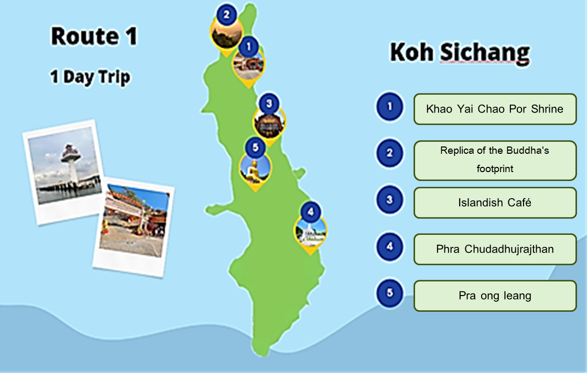
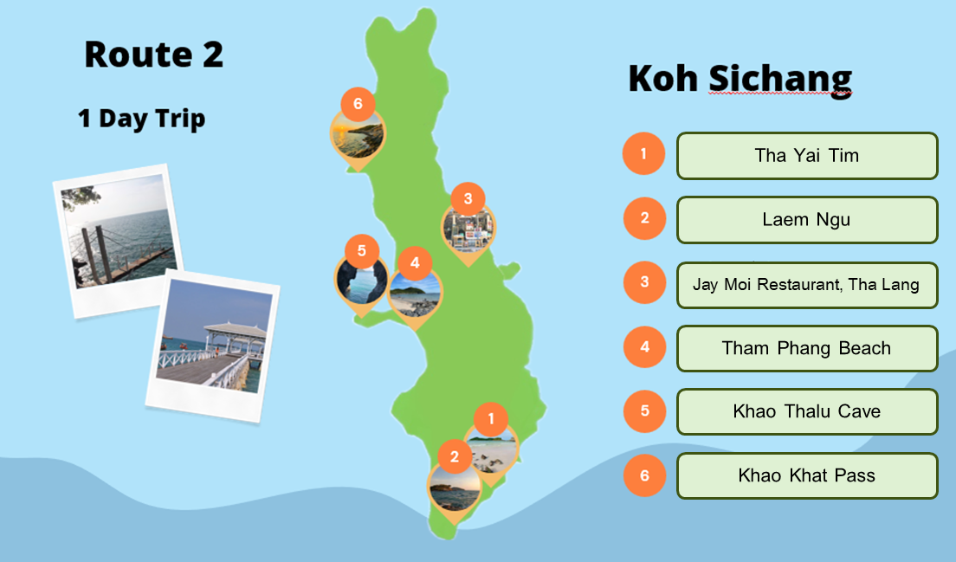
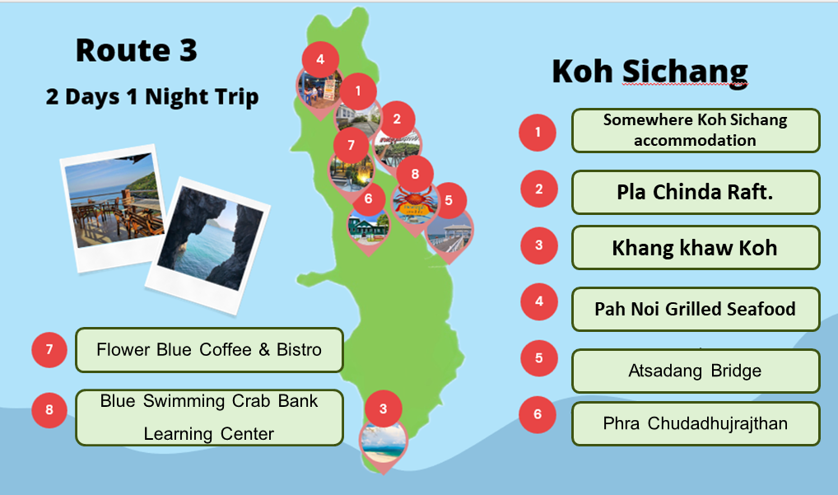

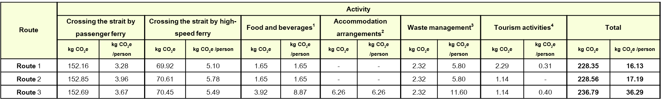
Table 1. Greenhouse gas emssions for travel routes along Sichang island

